Item List Version 2 Component

List Options

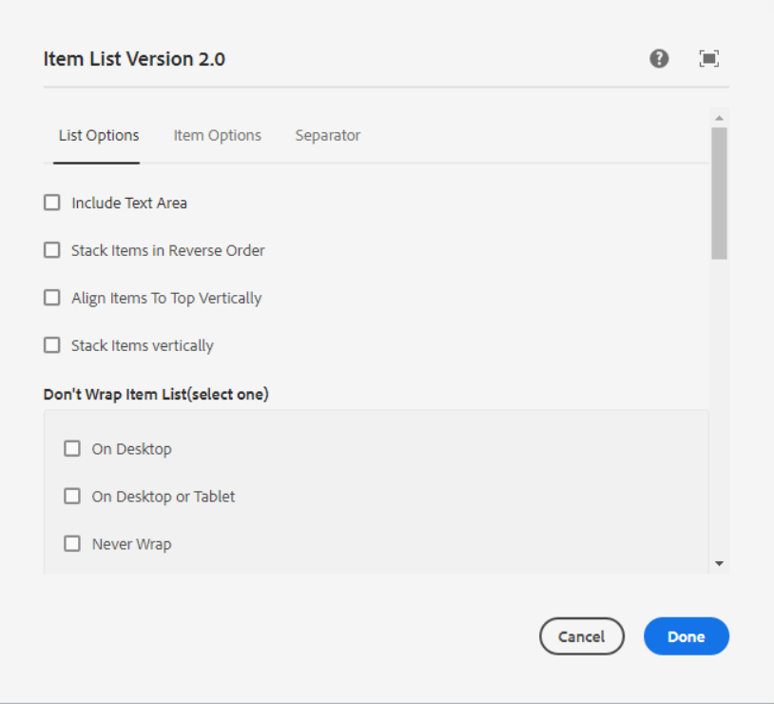

**Checkbox for Include Text Area** – If we want textbox before the list then we need to select this checkbox

**Checkbox for Stack Items in Reverse Order** – We can use this to items in reverse order

**Checkbox for Align Items To Top Vertically** – We can use this to align items to top vertically

**Checkbox for Stacks Items Vertically** – We can use this to stack items vertically

------------------------------------------------------------------------------------------------------------

**Don't wrap Item List (Select one)** - This is for wrap item list

**Checkbox for on Desktop**

**Checkbox for on Desktop or Tablet**

**Checkbox for Never Wrap**

------------------------------------------------------------------------------------------------------------

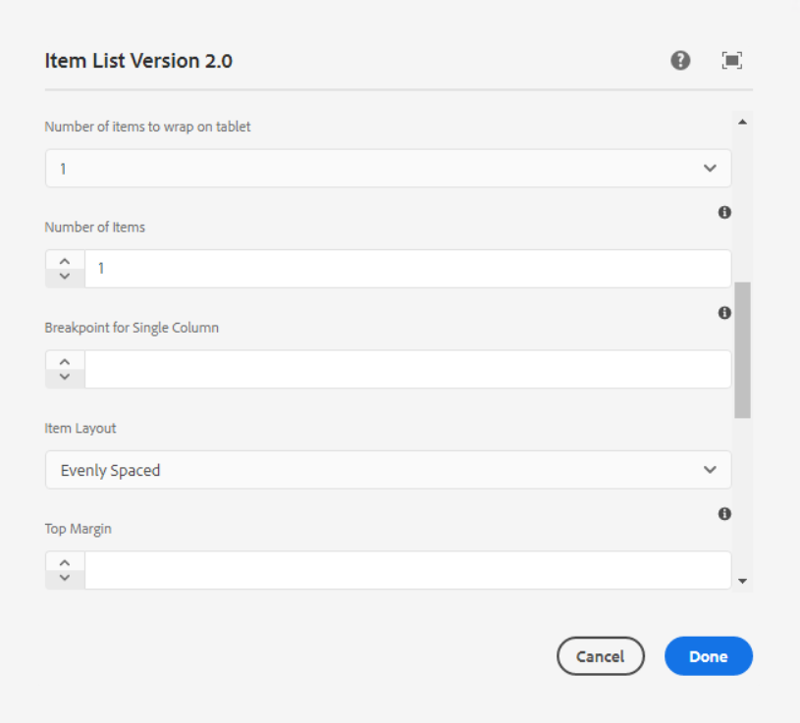

**Number of items to wrap on tablet** – Select value from dropdown to show how much items we require on tablet.

**Number of items** - Number of items you want to include in the list

**Breakpoint for single Column** - Enter the width at which point the list should break to a single column. Leave blank for default breaking. NOTE: If a width is entered items will shrink until the specified breakpoint, then break to a single column.

**Item layout**

1. **Evenly Spaced**
2. **Centered**
3. **Space Between**
4. **Space Around**
5. **Left**
6. **Right**

**Top Margin** - Enter a top margin for the list.

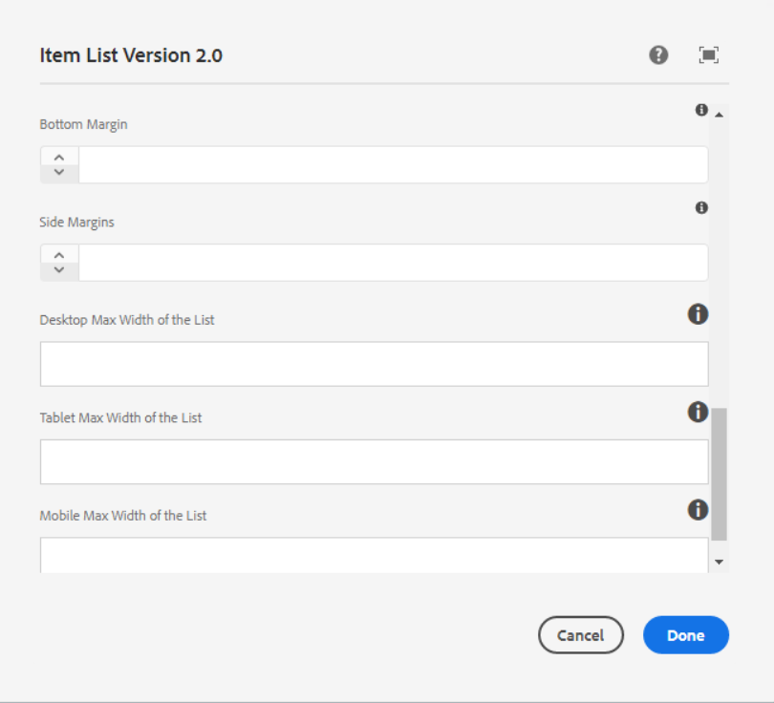

**Bottom Margin** - Enter a Bottom margin for the list.

**Side Margin** - Enter a side margin for the list.

**Desktop Max Width of the List** - Enter a desktop max width for the list.

**Tablet Max Width of the List** - Enter a tablet max width for the list.

**Mobile Max Width of the List** - Enter a Mobile max width for the list.

___________________________________________________________________

Item Options

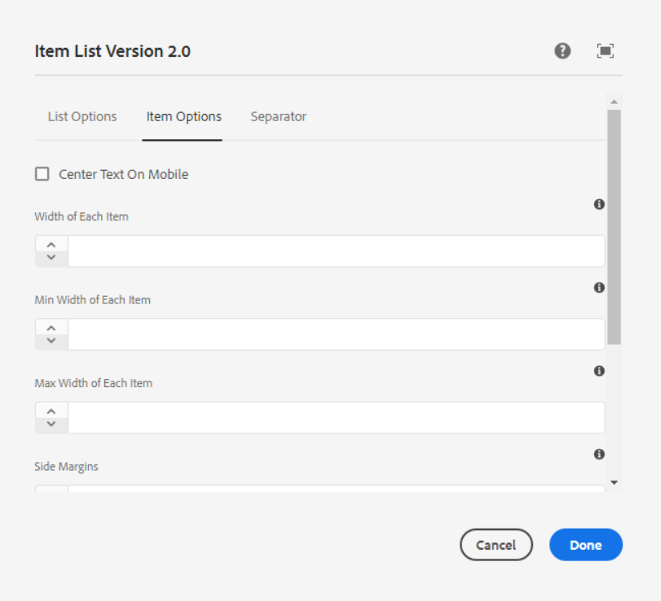

**Checkbox for Center Text on Mobile**

**Width of Each Item** – Enter an explicit width for each item (Px). Leave blank for auto.

**Max Width of Each Item** – Enter the max width of each item

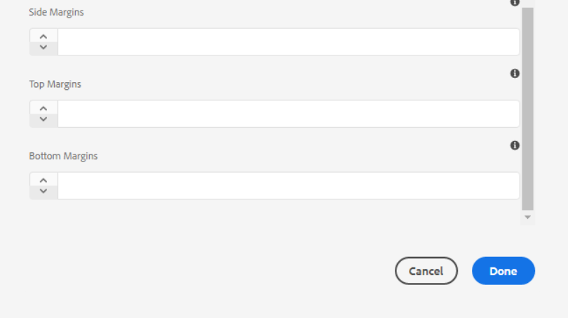

**Side Margins** – Enter the side margin for the list.

**Top Margins** – Enter the side top for the list.

**Bottom Margins** – Enter the bottom margin for the list.

___________________________________________________________________

Separator

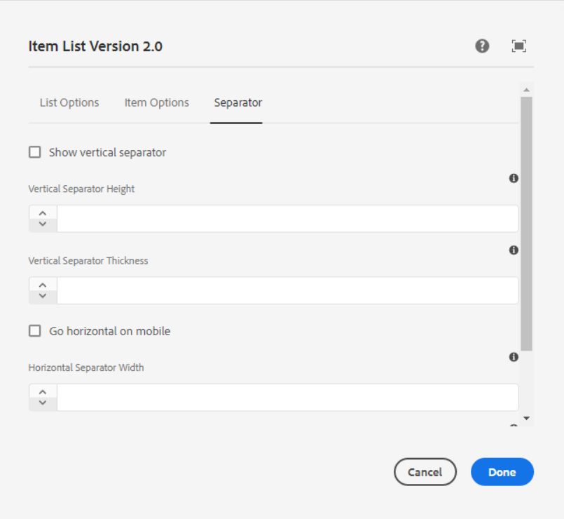

**Checkbox for show vertical separator**

**Vertical Separator Height** – Enter Height in PX. Leave blank for auto

**Vertical Separator Thickness** – Enter a thickness in px

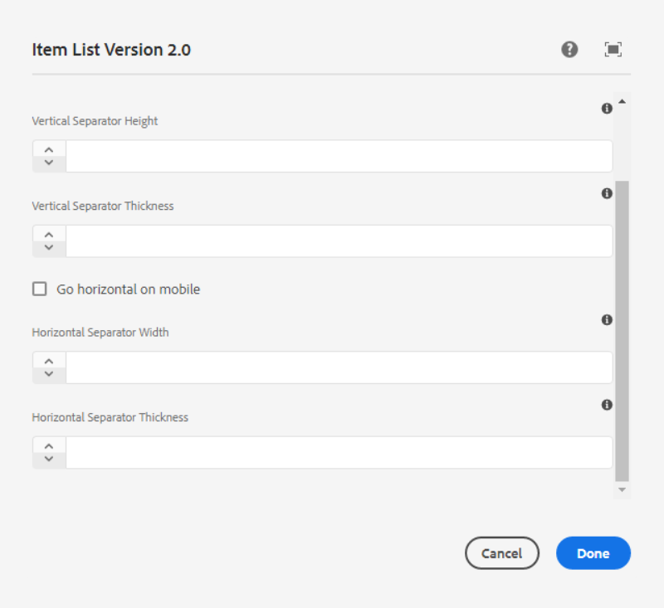

**Checkbox for Go Horizontal on mobile**

**Horizontal Separator Width** – Enter width in PX. Leave blank for auto

**Horizontal Separator Thickness** – Enter thickness in PX

___________________________________________________________________

Style Options

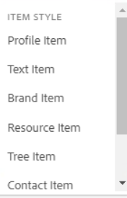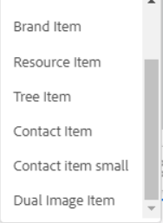

**Item Style**

1. **Profile Item**

Page Reference - <https://www.ancestry.com/corporate/about-ancestry/our-team>

AEM URL - <https://author-ancestry-dev2.adobecqms.net/content/ancestry-corp/us/en/about-ancestry/our-team.html?wcmmode=disabled>

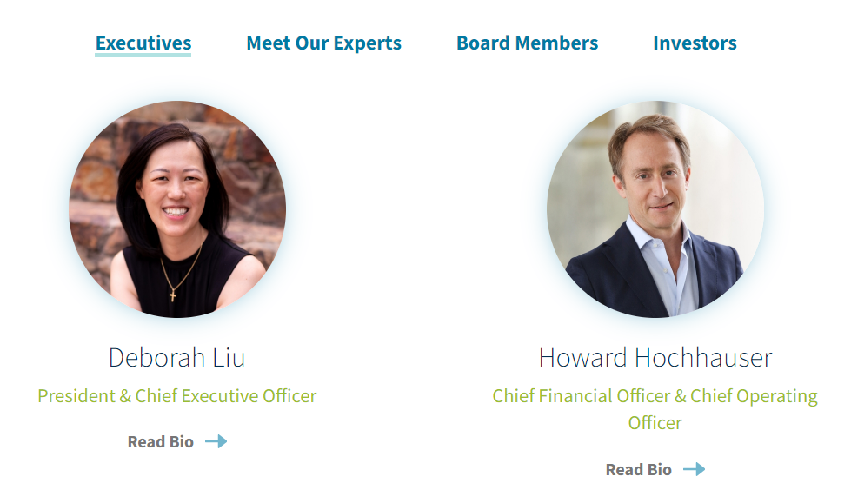

1. **Text Item**

Page Reference - <https://www.ancestry.com/corporate/about-ancestry/our-team>

AEM URL - <https://author-ancestry-dev2.adobecqms.net/content/ancestry-corp/us/en/about-ancestry/our-team.html?wcmmode=disabled>

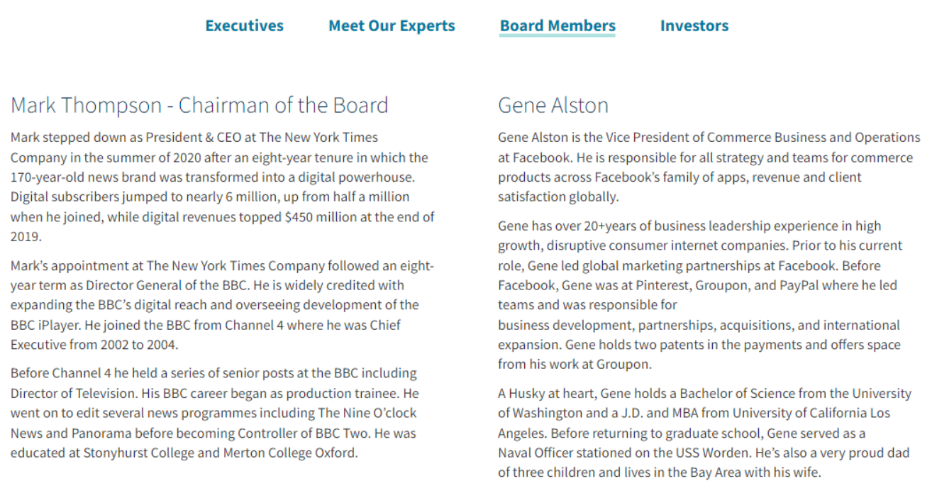

1. **Brand Item**

Page Reference - <https://www.ancestry.com/corporate/about-ancestry/our-brands>

AEM URL - <https://author-ancestry-dev2.adobecqms.net/content/ancestry-corp/us/en/about-ancestry/our-brands.html?wcmmode=disabled>

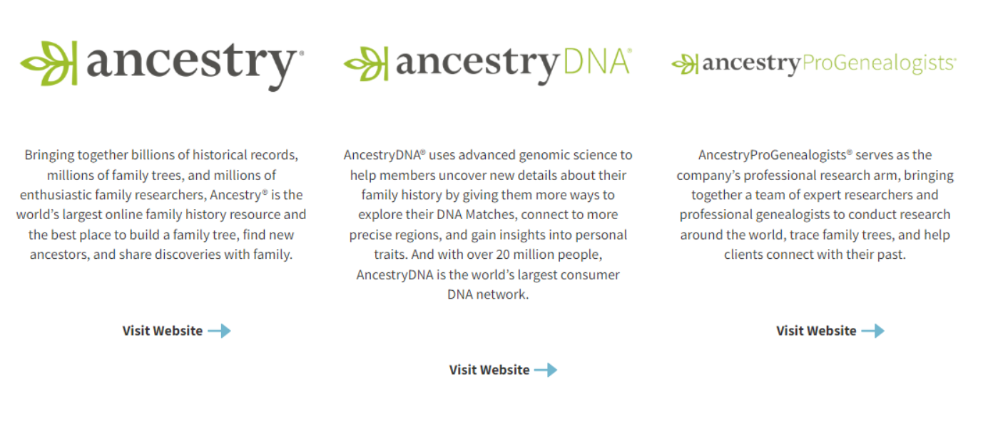

1. **Resource Item**

Page Reference - <https://www.ancestry.com/corporate/photo-library>

AEM URL - <https://author-ancestry-dev2.adobecqms.net/content/ancestry-corp/us/en/photo-library.html?wcmmode=disabled>

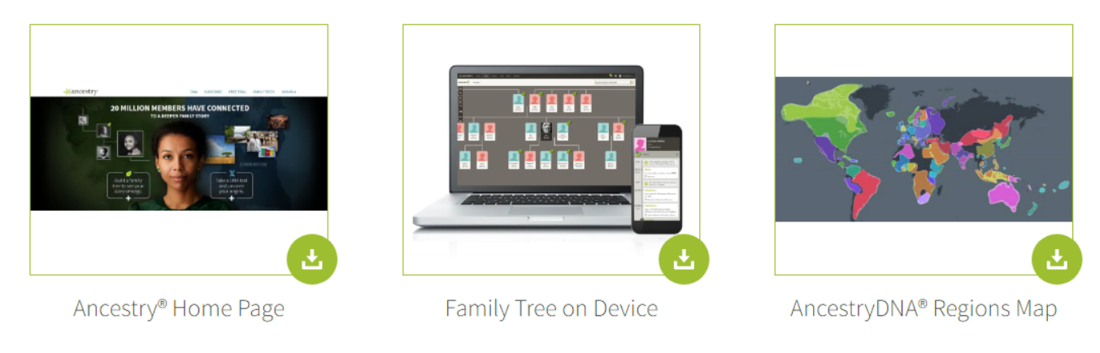

1. **Tree Item**

Page Reference - <https://www.ancestry.com/corporate/family-history-month>

AEM URL - <https://author-ancestry-dev2.adobecqms.net/content/ancestry-corp/us/en/family-history-month.html?wcmmode=disabled>

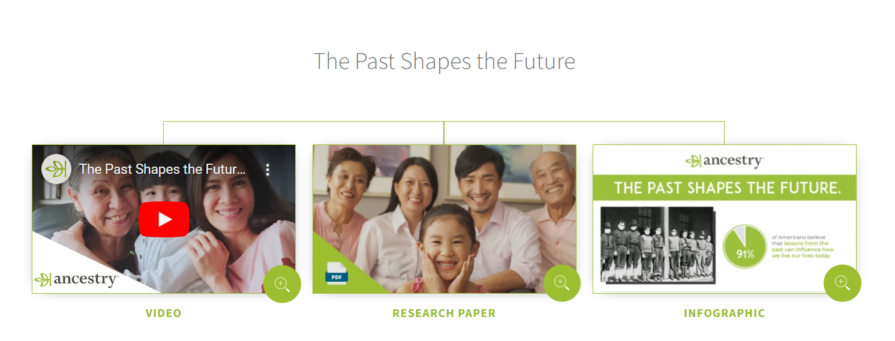

1. **Contact Item**

Page Reference - <https://www.ancestry.com/corporate/contact>

AEM URL - <https://author-ancestry-dev2.adobecqms.net/content/ancestry-corp/us/en/contact.html?wcmmode=disabled>

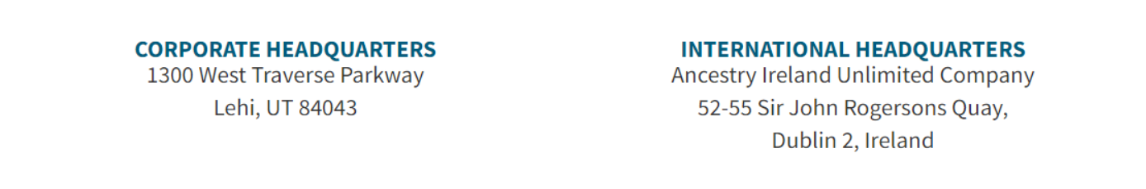

1. **Contact Item Small**

Page Reference - <https://www.ancestry.com/corporate/contact>

AEM URL - <https://author-ancestry-dev2.adobecqms.net/content/ancestry-corp/us/en/contact.html?wcmmode=disabled>

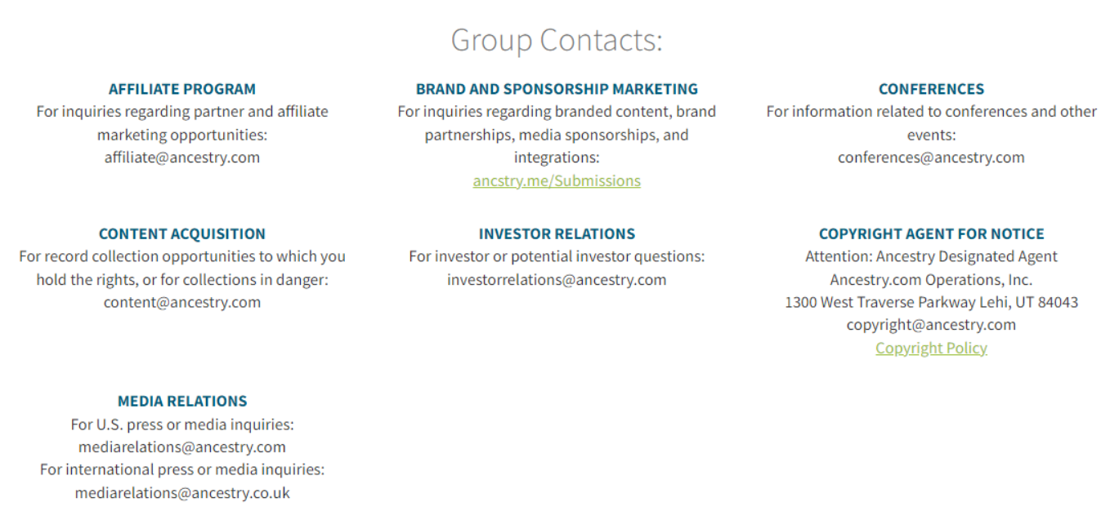

1. **Dual Image Item**

Page Reference - <https://www.ancestry.com/corporate/community-impact>

AEM URL - <https://author-ancestry-dev2.adobecqms.net/content/ancestry-corp/us/en/community-impact.html?wcmmode=disabled>

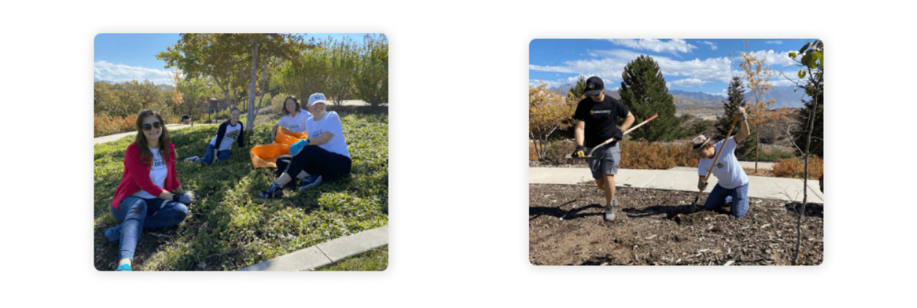

------------------------------------------------------------------------------------------------------------

After Adding Item list component, the content section is added automatically with image and text as per below screenshot.

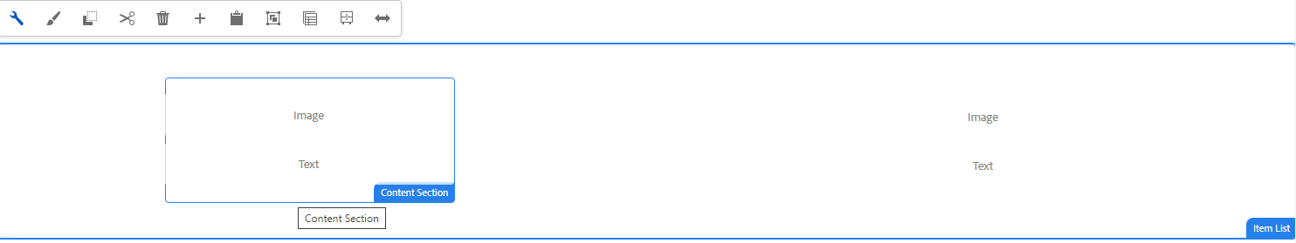

**Content Section Properties**

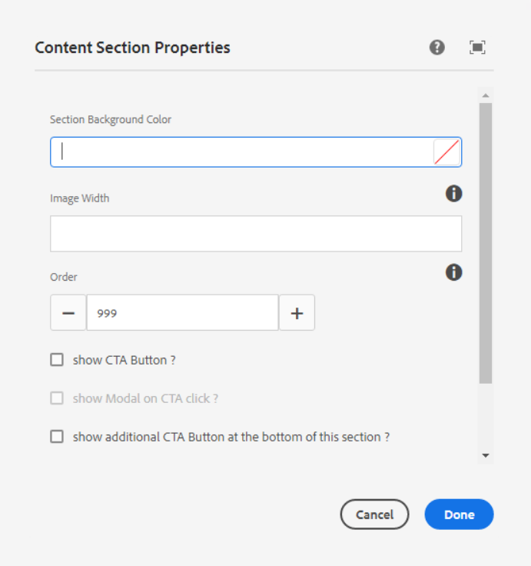

**Section Background Color** – We can give background color to item section using RGBA or HEX format.

**Image Width** - Enter the max width of the image Leave blank for none. Default is px. Example formats: (100px, 50%, none)

**Order** – Enter the order of the item.

**Checkbox for Show CTA Button?** - Check this if require CTA button after text field

------------------------------------------------------------------------------------------------------------ **Checkbox for Show Modal On CTA Click?** - Check this if require to show modal popup. This field is visible only for Profile item variation.

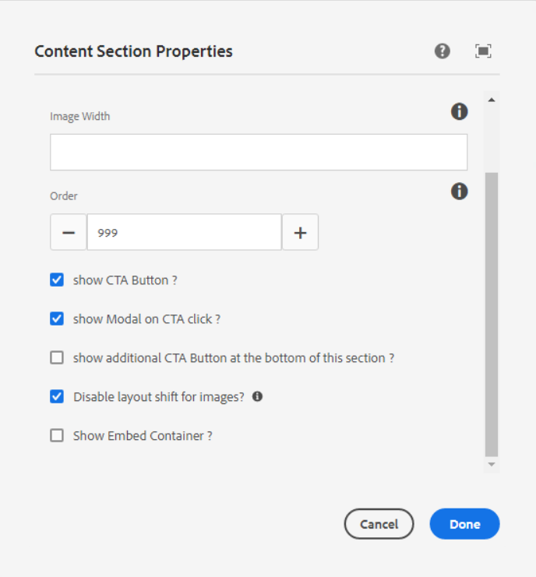

If we click on this then modal component will show before button as per below screenshot

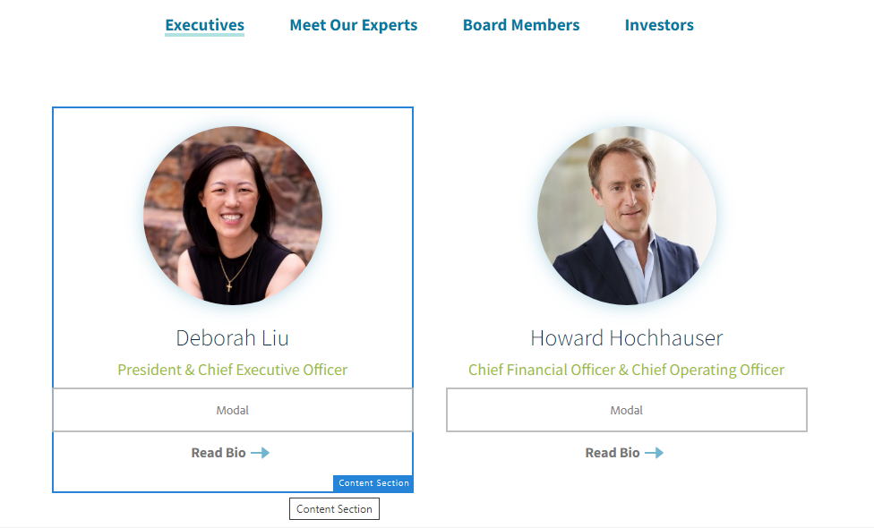

If we configure modal then it will show as per below screenshot.

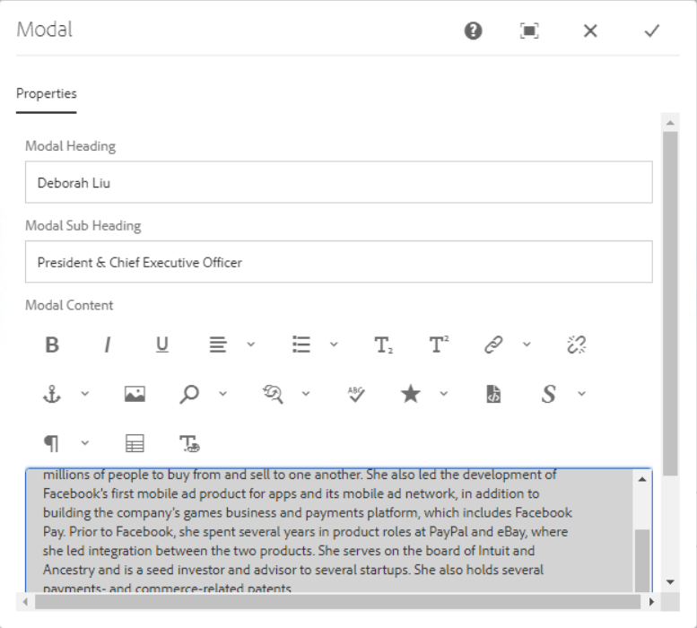

**Properties**

**Modal Heading –** This is for Heading.

**Modal Sub Heading –** This is for Sub-Heading.

**Modal Content –** This is for Content

Page Reference - <https://www.ancestry.com/corporate/about-ancestry/our-team>

AEM URL - <https://author-ancestry-dev2.adobecqms.net/content/ancestry-corp/us/en/about-ancestry/our-team.html?wcmmode=disabled>



When we click on Read bio link, then modal will show as per below screenshot.

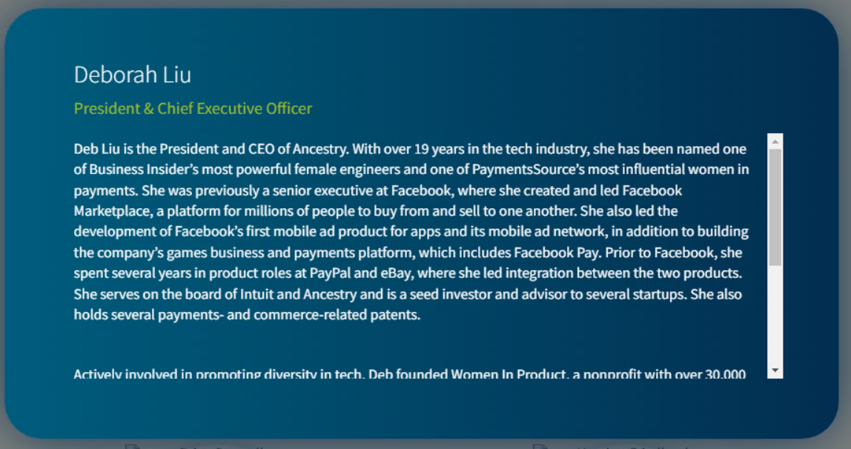

------------------------------------------------------------------------------------------------------------

**Checkbox for Show additional CTA Button at the bottom of this section?** - Check this if require addition CTA button after text field

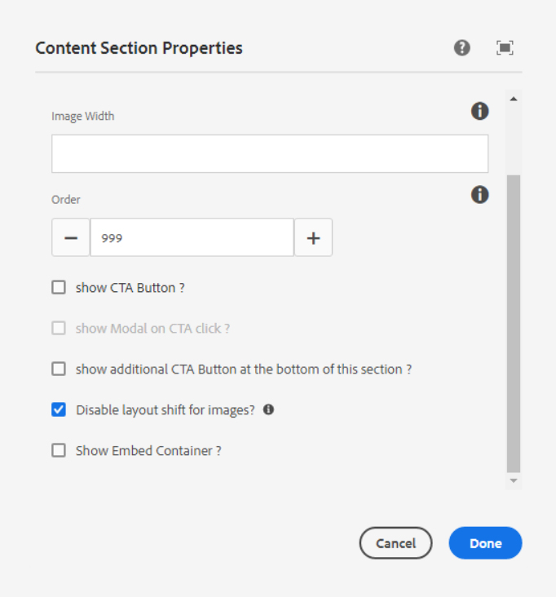

**Disable layout shift for images?** - This will help with performance, uncheck this box in case of authoring small images or icons having width or height less than 100px.

------------------------------------------------------------------------------------------------------------

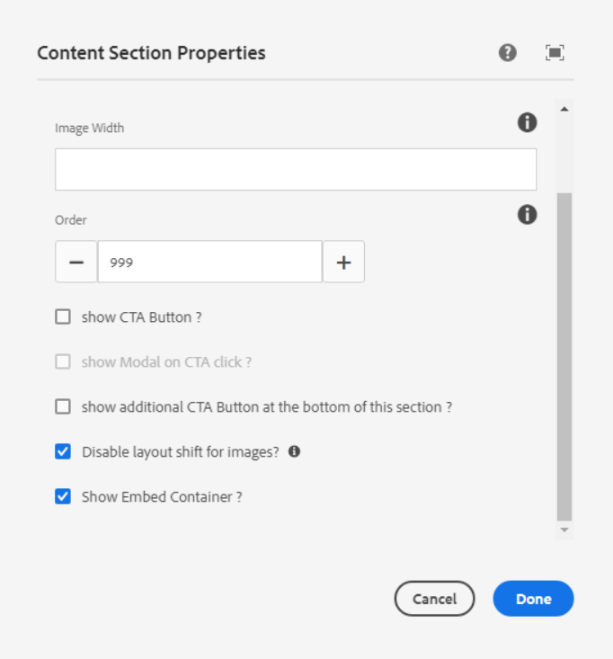

**Show Embed Container** – If we select this checkbox then default container will added inside that we can add or drag Embed component. Then author Embed component to show the video.

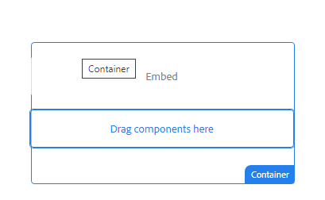

Page Reference - <https://www.ancestry.com/corporate/family-history-month>

AEM URL - <https://author-ancestry-dev2.adobecqms.net/content/ancestry-corp/us/en/family-history-month.html?wcmmode=disabled>



------------------------------------------------------------------------------------------------------------